**Can You Guess My Favorite Number**

***RevEng***

**Challenge:**

Attached - decompileMe.dll, decompileMe.runtimeconfig.json

**Approach:**

While the right way would be to actually decompile it, BUT, im gonna do what i do first, notepad!!

We just search for the flag format “CTFWU” and we got it lol

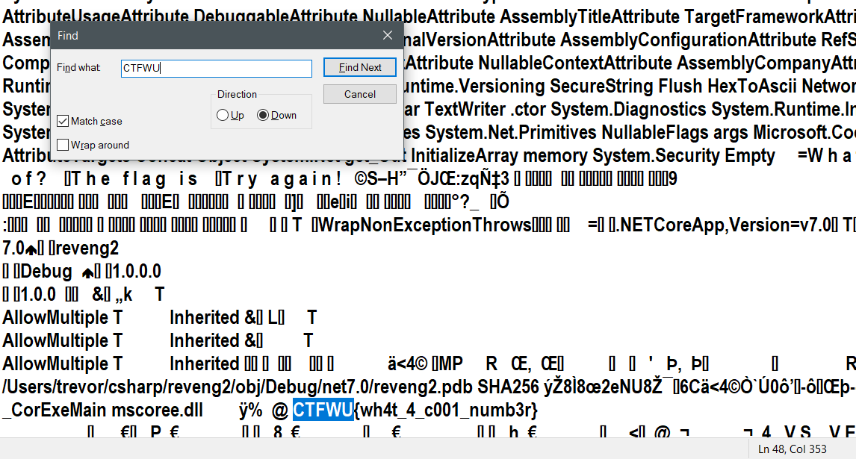

This is definitely not how RevEng questions should be solved, but hey, it sometimes work lol

**Flag: CTFWU{wh4t_4_c001_numb3r}**

Congrats!!

Happy Hacking!